# How to store Password in Database securely?

The safest way to store passwords in a database is by using a combination of hashing and salting techniques. Here's how it typically works:

1. **Hashing**: Instead of storing passwords in plaintext, they are first converted into irreversible hashes using cryptographic hashing algorithms such as SHA-256 or bcrypt. Hash functions convert the password into a fixed-length string of characters, making it computationally infeasible to reverse-engineer the original password from the hash.
2. **Salting**: To further enhance security, a unique random value called a "salt" is added to each password before hashing. Salting ensures that even if two users have the same password, their hashes will be different because of the unique salt. This mitigates the risk of rainbow table attacks, where attackers precompute hashes for commonly used passwords.
3. **Store Hash and Salt**: Both the hashed password and the salt are stored in the database. When a user attempts to log in, the stored salt is retrieved and combined with the provided password. The resulting value is hashed, and then compared with the stored hash. If they match, the password is considered valid.

By using hashing and salting techniques, even if an attacker gains access to the database, they won't be able to obtain the original passwords. They would need to perform a brute-force attack, trying various combinations to guess the passwords, which is computationally expensive and time-consuming.

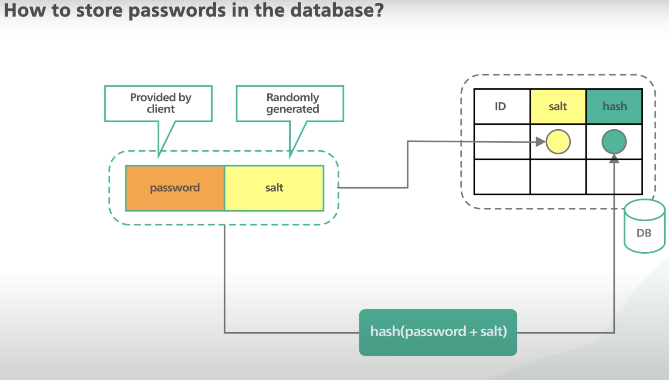

It's also important to use a strong and slow hashing algorithm like bcrypt, which is specifically designed for password hashing and includes features like a configurable cost factor to increase the computational complexity of hashing, making it more resistant to brute-force attacks.

# Rainbow Attack?

A rainbow attack is a type of brute-force attack used to crack password hashes. It exploits the vulnerability of using unsalted or poorly salted hashes to store passwords in a database.

Here's how a rainbow attack typically works:

1. **Hash Generation**: The attacker begins by generating a large set of precomputed hashes for commonly used passwords (dictionary words, common phrases, etc.). This set of precomputed hashes is known as a "rainbow table."
2. **Database Access**: If the attacker gains access to the hashed passwords stored in a database (typically through a data breach or other means), they can compare these hashes against the precomputed hashes in the rainbow table.
3. **Comparison**: The attacker compares the stolen hashes against the precomputed hashes in the rainbow table. If a match is found, it means that the original password corresponding to that hash is present in the rainbow table.
4. **Password Recovery**: Once a match is found, the attacker can determine the original plaintext password associated with the hashed password. They can then use this information to gain unauthorized access to user accounts.

Rainbow attacks are particularly effective against unsalted or poorly salted hashes because the rainbow table contains precomputed hashes for a wide range of possible passwords. Salting passwords with unique random values before hashing helps mitigate the effectiveness of rainbow attacks because each salted hash is unique, even if the original password is the same.

To protect against rainbow attacks, it's essential to use strong and unique salts for each password and employ robust cryptographic hashing algorithms (such as bcrypt or SHA-256) with a sufficient number of iterations to slow down the hashing process and make it computationally expensive for attackers to crack passwords. Additionally, regularly updating passwords and implementing multi-factor authentication (MFA) can further enhance security and mitigate the risk of successful attacks.